**ODT SureTyper Import Instructions**

1. Click import button in the spreadsheet
2. Locate the XML file that SureTyper automatically creates (if you are not sure where it is go into Manage > Folders in SureTyper and you’ll see the path where SureTyper is saving the XML folders).
3. Double click on the XML file for your sample and it will pull the type into the spreadsheet automatically
4. After having filled in the patient details and importing the type you can save as PDF to send to ODT. Just select PDF from the drop down menu when you save to save it as this option

A couple of things to note:

* The XML file is created when the SureTyper session is saved – therefore if there are any incomplete calls on any loci these all have to be rectified before the session is saved. If the session is saved before all the HLA types are assigned the XML file won’t have all the data and that loci will be blank when the type is imported
* The type imported is the first 2 common alleles in each HLA string, e.g DRB1*04:01/02, these are the alleles that are bold on the printed report from SureTyper. There may be more common alleles further down the string which aren’t imported. If there is only 1 common allele in the string it is imported with an XX to represent a string (e.g B*08:01/XX). There is a comment in the comments box stating this
* If there is not a common allele in the string it will import the serological type but leave the allele box blank (except for DP where it will leave the whole box blank as there is no serology) – this has an effect on DPB1*104:01 which comes up as rare so will not populate the DP box, but is actually quite common, there is an option on SureTyper to define it as common so it comes up bold and will import if you want to do that
* Certain types import the serology slightly differently, for example a B*39:01 will import with B39/B3901 in the split result and B*39 in the molecular box. If the allele you are reporting has its own antigen in the ‘Donor Antigens Excluded’ box on the ‘Unacceptable Antigen Mapping Chart from ODT’ attached, the make sure the type in the molecular box is only 2 digits (B*39 as oppose to B*39:01)

**Spreadsheet protection**

I have protected the spreadsheet as far as I can to comply with potential questions from UKAS inspectors. Only the key boxes can be manually altered and the code is also password protected, to unprotect and re-protect different areas please see instructions below:

**Protection instructions**

To unprotect worksheet:

In Excel click Review > Unprotect sheet > password is ‘ODT’

To re-protect certain parts:

* Click Review > Allow users to Edit Ranges

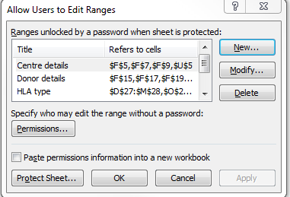

* The different parts of the spreadsheet are protected in different sections
* To alter protection in the centre details, click Centre details and Modify

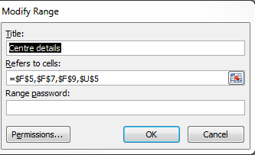

* Click here and select the cells that you want to editable (hold down Ctrl to select cells that aren’t next to each other)
* Click OK when done
* 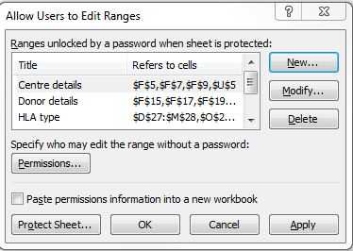
* Back on this box click Protect Sheet to lock the rest of the spreadsheet
* 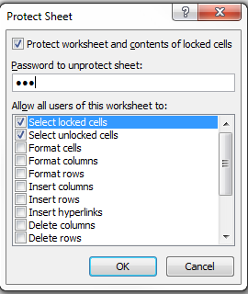
* Make sure box looks like this:  and enter password twice, click OK